**16-BIT DIVISION**  
**EXP NO: 8**  
  
**AIM:**To write an assembly language program to implement 16-bit divided by 8-bit using 8085 processor.  
  
**ALGORITHM:**  
  
1)      Read dividend (16 bit)  
2)      Read divisor  
3)      count <- 8  
4)      Left shift dividend   
5)      Subtract divisor from upper 8-bits of dividend  
6)      If CS = 1 go to 9  
7)      Restore dividend  
8)      Increment lower 8-bits of dividend  
9)      count <- count - 1  
10)  If count = 0 go to 5  
11)  Store upper 8-bit dividend as remainder and lower 8-bit as quotient   
12)  Stop  
  
  
**PROGRAM:**

LDA 8501

MOV B,A

LDA 8500

MVI C,00

LOOP: CMP B

JC LOOP1

SUB B

INR C

JMP LOOP

LOOP1: STA 8503

MOV A,C

STA 8502

RST 1

**INPUT & OUTPUT**

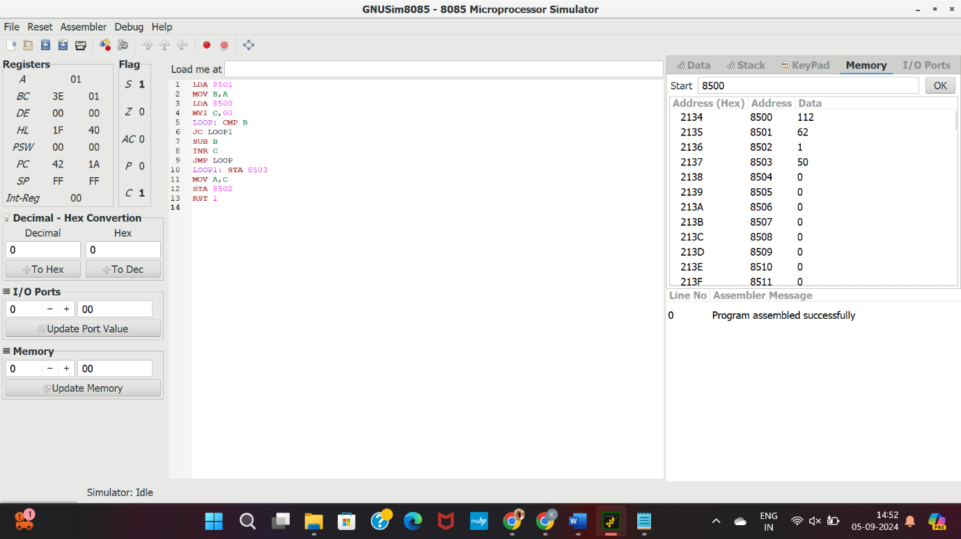

**RESULT:**Thus the program was executed successfully using 8085 processor simulator.